**12. Convert a string to lowercase.**

**Exercise**

* **Write a program to convert a string to lowercase. This string is given by the user.**

**Approach:**

**So here we did like this  
Java : in java The toLowerCase() method converts a string to lower case letters**

**Python : in Python, the “ .lower” method is used to convert a string in lower case !**

**Solution 👇**

**Java :**

**import java.util.Scanner;**

**public class CodeXam {**

**public static void main(String[] args) {**

**Scanner sc = new Scanner(System.in);**

**System.out.print("Enter any sentence or word: ");**

**String string = sc.nextLine();**

**string = string.toLowerCase();**

**System.out.println("In lower case this word or sentence looks like this : " + "\n" + string);**

**}**

**}**

**output:**

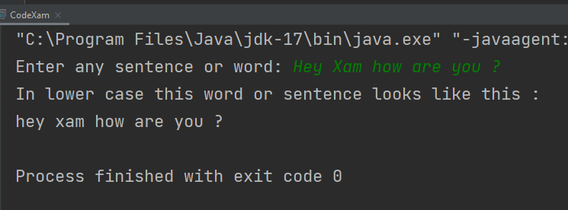

**Python :**

**given_str = input("Enter any sentence or word : ")**

**print("In lower case this word or sentence looks like this :", given_str.lower())**

**output:**

